Coloma Township Park District
Board Meeting Agenda
November 12th, 2019
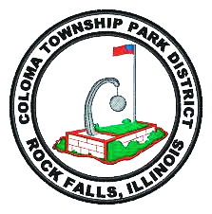
- Meeting Called to Order
- Approval of Minutes for October 8th, 2019
- Presentation of Bills from October 2019
- Executive Session
- Old Business
- Non-Referendum Bond Issue - December 1, 2019:
An Ordinance providing for the issue of $270,000 General Obligation Park Bonds, Series 2019, of the Park District, for the payment of land for parks, for the building, maintaining, improving, and protecting of the same and the existing land and facilities of the Park District and for the payment of the expenses incident thereto, providing for the levy of a direct annual tax sufficient to pay the principal and interest on said bonds, and authorizing the sale of said bonds to the purchaser thereof.
- Tax Levy - 2019/2020 proposed tax levy ordinance
- Dog Park - Millennial’s for change
- Dillon Check
- Sieglinger Park – Project Update
- New Shelter – Centennial Park Completion
- Treasurer's Report
- Tree Bid – Fall 2019 Documents

- New Business

- Lumberjack Show - Rock Falls Tourism Director Megan Horseman
- Whiteside County Collector – 5th Tax Distribution for 2019
- IPRF Grant
- IParks Inspection
- Personal Property Replacement Tax

- Other Business

A. Maintenance Report
B. Vandalism Report
C. Minimum Wage Change
D. Joyce Doyle’s Probationary Evaluation

IX. Adjournment

